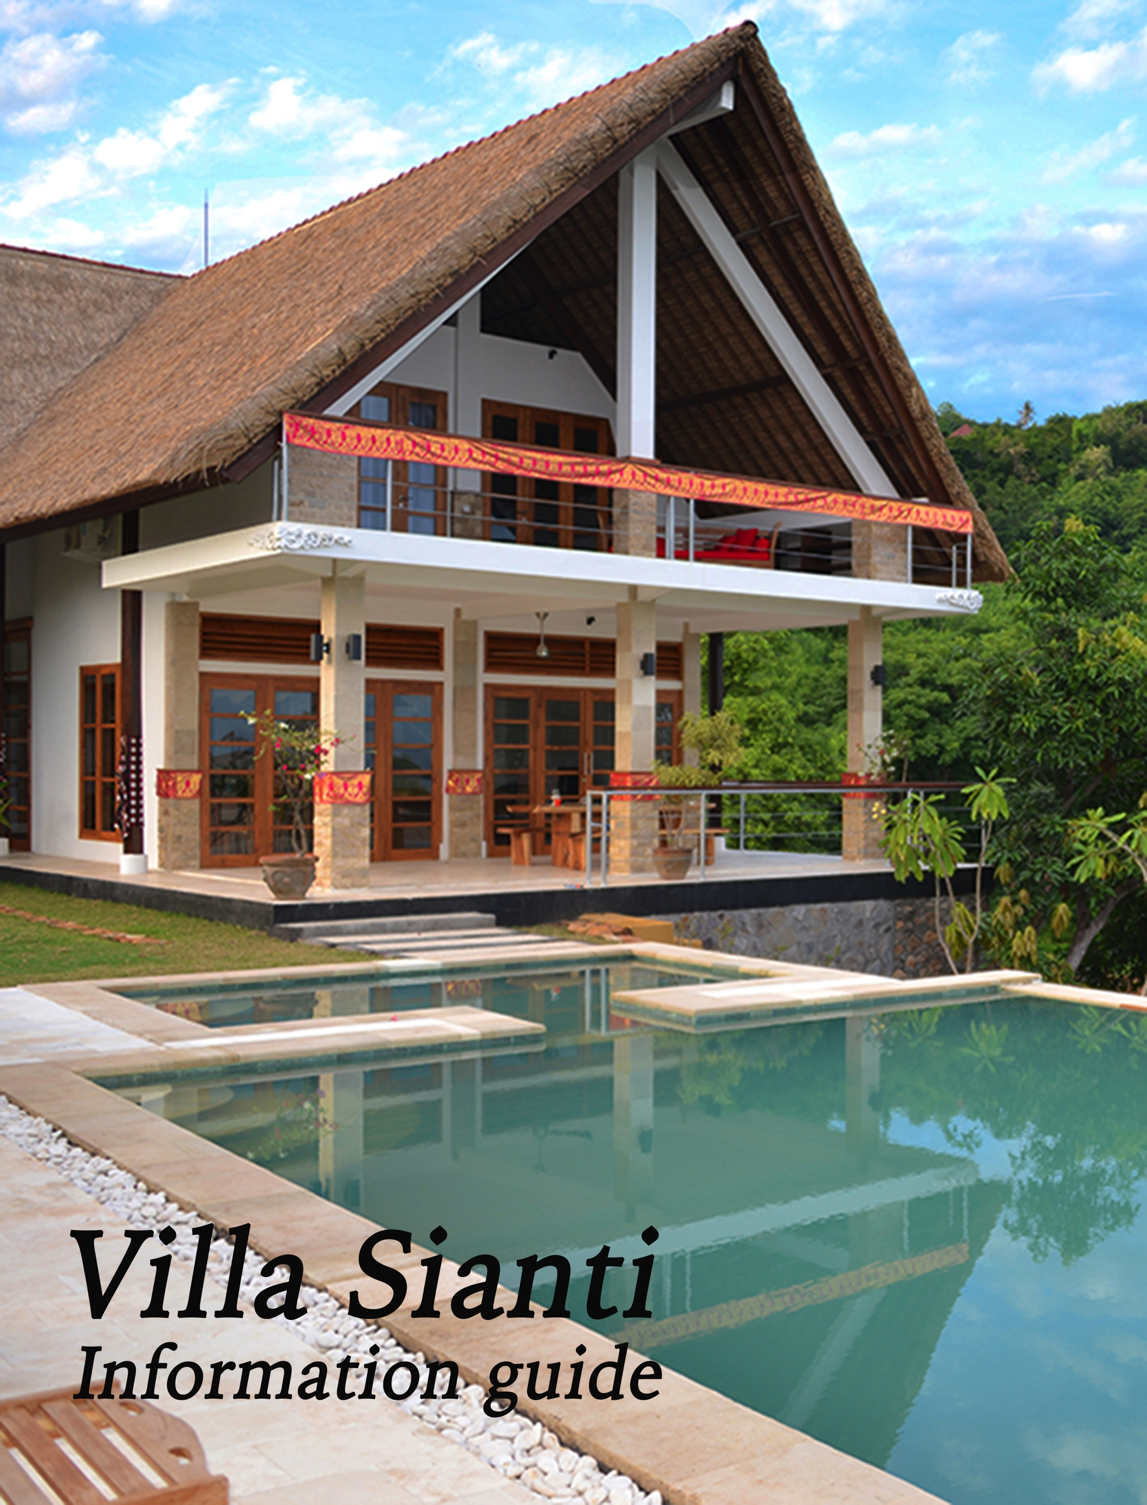

Villa Sianti
Restful, peaceful, beautiful

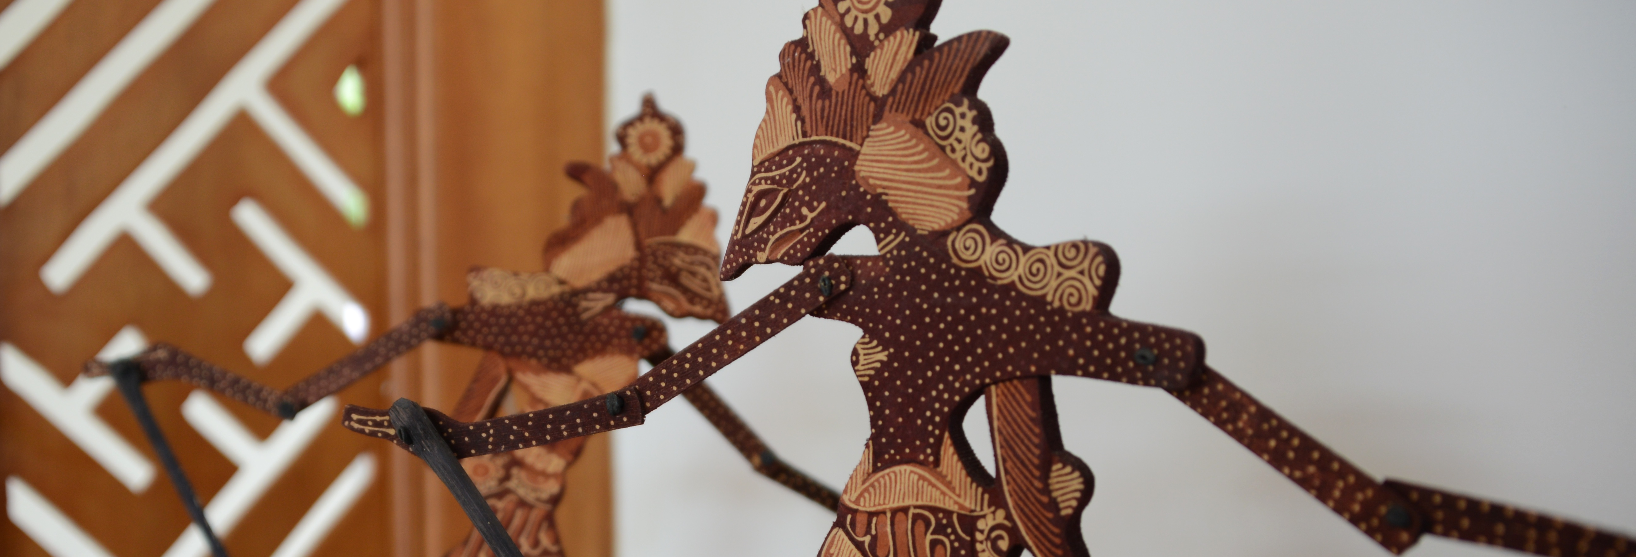

WELCOME!

We would like to extend a warm welcome to you in Villa Sianti.

Villa Sianti is a luxury villa equipped with all modern amenities. Friendly and hospitable staff will be at your service six days a week to make sure you have a memorable holiday.

This guide is designed to assist you during your stay and gives you important information about the villa, tips and suggestions for tours whilst you are here, contact information for local restaurants and the villa help desk, suggested menus and much more. We suggest that you read it thoroughly to make the most of your holiday.

Contents:

- Service and Staff
- Amenities
- Addresses and phone numbers
- Surroundings
- Menu suggestions

We hope you enjoy your stay at Villa Sianti and return to visit us again.
In the meantime, please ‘like’ our Facebook page (to keep up with all our news and updates.

Service and Staff

Arrival and departure

Unless a prior arrangement has been made, the villa is available from 2pm on the day of arrival. If you arrive during the day the staff will be there to prepare a welcome dinner for you on the first evening and breakfast the following morning, both of which are included in the villa rental.

If you arrive in the evening, the security guard will let you in and a meal will have been prepared which will only have to heat up. Also a welcome package will be provided which includes fruit, bread and various beverages in the fridge.

Unless a specific arrangement has been made, you are kindly requested to leave the villa before 12pm (noon) on the day of departure. If you are going directly to the airport we remind you that the journey takes approximately 3 hours and the check-in time is at least 2 hours prior to your flight departure for international travel.

Staff

The staff of Villa Sianti are available 6 days a week to make sure that you have a comfortable stay. Our staff consists of two housekeeper/cooks, who look after the entire household by maintaining the villa, taking care of the laundry & ironing and preparing your breakfast, lunch or dinner, a full time gardener who also maintains the swimming pool and an overnight security guard who is on duty from 6pm to 6am every day.

The housekeepers and gardener do not work on a Sunday. However, if you arrive or depart on a Sunday they will be there to help and you can negotiate a suitable day for them to have off in lieu.

Their normal working hours are from 8am until 5pm with a 1-hour break in the afternoon.

The staff arrive at 8am and the cook will prepare your breakfast. Each day you can decide if you would like the staff to prepare your lunch and/or dinner. If you want the staff to prepare your dinner, they will be available until 8pm but will take a longer break in the afternoon. Alternatively, they can prepare your dinner in the afternoon and you can heat it up in the evening.

We suggest that each day you notify the staff of your preferences for meals the following day so they can buy the groceries. We kindly ask for your consideration in having some variety when asking them to prepare the dinner, so that they do not have to stay each night until 8pm or later.

Please bear in mind that nearby in Lovina there are plenty of nice, inexpensive restaurants.

The staff can prepare many different types of meals for you. You can choose what you would like to eat or make use of the suggested menus later in this information guide.

With some regularity, special ‘ceremonies’ are held in Bali so it is possible that there may be an additional day that the staff will not be available. The help desk will inform you about this in advance.

Groceries

Except for the welcome package, all groceries are at your own expense. For your daily groceries you can go to Lovina or Singaraja. In Lovina you will find a small supermarket (Angsoka) as well as a bakery: Bakery Lovina has a German owner and offers delicious bread and croissants. At the bakery you will also find luxury western meat, cheese and imported wines. You can also choose to have your bread delivered to the villa each morning. Buda Bakery & Resto is another local bakery that will deliver to the villa. In case you are looking for a bigger supermarket with more choice, you can go to Hardy’s, Carrefour or ADB in Singaraja (15 minutes drive).

Do you like fresh fish? A little bit further than Lovina, in the Anturan village, you can find a fish market. Coming from the direction of Lovina, the market is situated on the left side of the road and is named ‘Pasar Ikan’.

If you prefer, your staff can take care of your groceries. They can buy fresh vegetables, fruit, meat and fish at the morning market. If you would like them to buy fresh goods, we advise that you provide the staff with your shopping list one day in advance. You will have to give them money for the groceries and they will provide you with the receipts. Please take into account that not all places provide receipts (e.g. markets etc.). The staff is happy to take care of your groceries and they will only ask for a small amount to cover their transportation costs (Rph 20,000).

Another possibility is for you to go shopping at Carrefour on your way from the airport to the villa. Carrefour is located just 10 minutes from the airport and sells a lot of ‘Western’ products, which you cannot buy in the north of Bali.

Transportation

If you would like to use one of the drivers for going out for dinner, shopping or to enjoy a beautiful day trip around the island, you can always call the help desk (please refer to the list of drivers and phone numbers included in this guide). You can also make your own arrangements for your trip back to the airport in Denpasar with one of the drivers.
The drivers charge approximately rph 150.000 for a return trip to Lovina, rph 350.000 for a half-day tour and rph 700.000 for a full day tour or to go back to the airport in Denpasar (in a car suitable for 5 people plus luggage). We recommend that you agree on the price in advance. In case you are pleased with their service (especially for daytrips) you can always give them a tip. All drivers speak English and are also very good guides; they know the best places to visit in Bali! All prices are per vehicle, not per person.

If you book a local organized tour they often offer free transport from and to the villa. Some restaurants in Lovina also offer a pick up and drop off service if you make a reservation with them in advance (see or more details further in this guide under ‘Addresses’).

There is also local transport on Bali, but it is very irregular. There are mini-buses, called ‘bemos’, that drive along the main road along the north coast; they are usually a blue colour. If you walk along the main road you can signal to stop them. With a bemo ride you are able to go (for example) to Singaraja for a very small amount (approximately 20.000 rph). Please note that the bemos are only available during the day till 6pm.

Of course you can also rent a motorbike, bicycle, or a car yourselves if you dare to defy the traffic in Bali. Please note that you officially need to have an international drivers licence. If you require more information, please contact the help desk or the staff.

Help desk

During your stay you can always contact the help desk. Their phone number is in the phone list included in this guide. You can contact them every day for any questions you might have regarding the villa, the staff and the surroundings.

Tourist tax

In Bali it is required to register all guests at the tourist police. A day or two after your arrival, a staff member or the help desk will come to your villa to collect two copies of each passport and a fee of 30,000 rph per person. They will take
care of the registration with the tourist police. We recommend that you bring 2 copies of each passport along on your trip to Bali for this purpose.

Keys

On arrival you will receive keys to the doors of the Villa. On the day of departure, please return these keys to the staff.

Inventory

The inventory of the villa caters for 8 persons (max. 6 adults). You will find towels for the bathrooms and towels for the swimming pool in the bedrooms and bathroom. The staff will ensure that these are washed on a regular basis. The staff will check the inventory upon arrival and departure. In case of damage or missing items, the related costs will be deducted from your deposit.

Thanking staff

The staff of the villa will do their utmost to make your stay as pleasant as possible. Whether you want to show your appreciation for their services is entirely up to you.

On our first visit to a villa in Bali we were unsure what to leave as a tip so, as an indication, may we suggest that if you do choose to leave a tip, a suitable amount would be between 100,000 rph and 200,000 rph per staff member per week. This is from the guests as a group, not individually.

Naturally, tipping is not mandatory and completely at your own discretion. Whilst tips are not expected, they are gratefully accepted.

Amenities

Swimming pool

Villa Sianti has a beautiful, large private swimming pool. The gardener will take care of the maintenance of the pool on a daily basis. The water in the pool is filtered through the pump system, so it is therefore recommended to leave the pump on during swimming hours (normally the gardener will turn the pump on in the morning). We kindly ask you to turn off the pool lights and pump before going to bed.

TV / DVD / STEREO

In the villa you will find a 2 televisions and 2 DVD players. There are a variety of DVD’s available in the villa (including some children’s movies), but please feel free to bring along some of your own.
The villa also has a Bluetooth speaker system that will connect to any modern device with Bluetooth capabilities so make sure to bring plenty of your favourite music with you.

Telephone

The villa does not have a telephone. Therefore we advise you to take a mobile phone with you. If you want to save money you can buy a local calling card (prepaid sim card). There are a number on telecommunication companies in Bali and these cards can be brought at several shops in Lovina or Singaraja.
They offer very good rates for phone calls and text messaging in Bali and also have attractive rates for foreign calls.

For local calls and text messages in Bali you just dial the local number (starting with 0).

Internet

The villa has wi-fi that is included in the cost of the villa rental.
The staff will advise you of the login and password on arrival.

Safety deposit box

In the villa you will find a safety deposit box (located in the main downstairs bedroom) for all your valuables. You can open and close it with your own personal code. For instruction on the use of the safety deposit box please read the instructions supplied or ask the staff. At departure, we kindly ask you to leave the door open for the next guests.

Banking

In general, Indonesian Rupiah is still the preferred means of payment in Bali. Only hotels, restaurants and larger stores accept credit cards. In Lovina and other cities such as Singaraja you will find ATM cash machines where you can withdraw Indonesian Rupiah. Keep in mind that you can often only withdraw a small amount at a time and the amount can differ between ATM’s.

You can exchange foreign currency at the airport in Denpasar at one of the money exchange offices located around the meeting area. In Lovina you can also exchange money at the Tip Top Money changer (on the main road through Lovina next to the Hotel Chonos) or use a Cirrus card at many of the local convenience stores.

Visa on Arrival

Many nationalities require a Visa to enter Indonesia. If you are staying less than 30 days (29 nights), you can purchase a Visa on Arrival (VOA) at the airport. The cost is USD 35 per person but can be paid in a variety of currencies at the equivalent rate of exchange on the day.

The day of arrival and the day of departure are both included in counting the days available as part of the visa. Please also make sure your passport is valid for at least 6 months from your arrival in Indonesia and that and there are at least two blank pages in it.

If you plan to stay longer than 30 days in Bali (or Indonesia) you will have to apply for a visa in advance at the Indonesian Embassy in your home country.

Current information regarding Visas for Indonesia can be found at the following site: www.visabali.com

Kitchen equipment

Villa Sianti has a fully equipped kitchen with all necessary appliances such as a refrigerator, gas cook top, microwave oven, toaster, rice cooker, blender, sandwich maker, coffee maker etc. There is also a second small bar fridge located under the stairs in the living area.

Drinking Water dispenser

We do not recommend you drink the water from the tap. For your convenience in the kitchen you will find a water dispenser that supplies normal, hot or cold water. You can buy a new water tank in almost every store. They are inexpensive and, if you return the empty container, you will receive a refund. You can ask the staff to buy a new water container for you.

Laundry

The villa has a washing machine, which you are free to use. You can also ask the staff to wash your clothes and iron them. Please note that this is at your own risk and responsibility. We encourage you to give instructions to the staff, especially if it concerns clothes that are very delicate and require special treatment or ironing.

Toilets

The toilets are connected with a septic tank. You are therefore urged to only flush toilet paper and to use the bins provided in all bathrooms for other hygiene products. All toilets in the villa are equipped with a dual flush system for water conservation (half flush or full flush) and we request you utilize this facility.

Voltage

The voltage in Bali is 210/220V. The plugs on Bali are of the same type as the standard European two prong power plugs. There is a variety of power adapters supplied at the villa covering different countries, but we recommend that you bring your own to guarantee your electrical products can be used successfully.

Electricity & Water

Electricity is very expensive on Bali and water is scarce. We encourage you to be sensible in the use of electricity and water.

You can save energy by turning off the air conditioning when you are not in the bedrooms and also turning off fans and other devices when they are not in use. Please close doors and windows when the air conditioning is running.

The bedrooms cool down very quickly once the air conditioner has been turned on so, if using the air conditioners overnnight, you need only to turn them on shortly before going to bed.

Keeping the doors to the bathrooms closed will also avoid any unwanted insect visitors and optimise the air conditioners.

To save water, sheets and towels will be washed upon request. Please leave your bath towels on the floor if you wish them replaced and leave the supplied ‘change sheets’ card on your bed when you wish to have them replaced.

Addresses and phone numbers

Address of Villa Sianti

Villa Sianti

Sing Sing Villas
Jalan Air Terjun Sing Sing
Temukus / Lovina
Buleleng - Bali

Help desk & Drivers

For all your questions related to the villa, staff and surroundings or to arrange a driver please contact the help desk:

Diah 0877 6228 1659
Putu 0878 6328 5591

If you are not using a local sim card, please add +62 and drop the leading (0)

Supermarkets

Lovina: Angsoka, Jalan Raya Lovina (small grocery for drinks, chicken and fish from the freezer, chips, biscuits, milk)
Singaraja: Hardy’s, Carrefour (bigger supermarket with butcher, fish, fresh vegetables and fruit and dairy) and ADB (also supermarket with a lot of fresh food)
Seririt: Hardy’s (small supermarket on the main street in the centre of Seririt)

Bakery

Fresh baked bread and croissants can be bought at the Bakery Lovina located on the main road of Lovina just past the lights on the left heading towards Singaraja. They also sell fresh cheese, dairy products and international wines and spirits. To order in advance or arrange a delivery, please call 036242225. The Buda Bakery & Resto – which is harder to find but with an excellent reputation – will also deliver to the villa for a small fee. Phone 036242106

Alcohol

The Bakery Lovina and Alcovino (opposite the Spice Beach Bar) offer local and imported wines and imported spirits at very reasonable prices.

Home delivery

A number of restaurants in Lovina offer home delivery of meals:

Arias (Chinese and Indonesian Food): 036241341
Chonos (Indonesian and western Food): 036241569
Jasmine (Thai Food): 036241565

Restaurants

Lovina offers a wide variety of restaurants: from small Indonesian warungs to the more western oriented restaurants. We can recommend a visit to the following restaurants:

*Spice Beach Club Bali, Jl. Raya Singaraja 085100012666
*Starlight Restaurant, Jl. Starlight Lovina 03627005271
**Le Jaenzan Restaurant Jalan Raya Singaraja 03623435624
Jasmine kitchen, Jalan Bineria 036241565 (Thai)
Seyu Japanese Restaurant, Jalan Bineria 03627061888 (Japanese)
Kakatua, Jalan Bineria 036241144 (Western & Asian)
Pappagallo Pizzeria, Jalan Binaria 036241163 (Italian)
*Chonos, Jalan Raya Singaraja 036241569
*Damai, in the hills of Lovina, luxury 036241008
Ikan Bakar Harga Lokal 0362-41223 (Seafood)
Warung Aria, Jl. Rata Lovina no. 18 036241341 (Chinese)

*offer pick up & return service free of charge
** IDR 100,000 return service (but well worth it!)

Spa

Do you like to relax with a massage?
Within 5 minutes walk of the villa you will find a Spa for pampering massages. The staff of your villa can make a reservation for you or you can call Ketut for a booking on 081 936 654 165. Alternatively, you can arrange to have the massage staff come to you at the villa.

There are many massage options in Lovina. Most of the large hotels will have a spa and there are also many small shops offering massage & beauty services.

Doctor and dentist

In case you need a doctor or a dentist you can contact:

Dr. Handra
Practice 0362 23798
Mobile 081 236 057 33

Dr. Made
Practice 0362 41314
Mobile 081 915 704 050

Dentist Dr. Hilda
Practice 0362 26200
Mobile 081 2395 1683

They all speak good English. Dr. Made also has a pharmacy in Lovina called “RAHAYU”.

Hospital

The closest hospital is in Singaraja:

Rumah Sakit Umum
Parama Sidhi
036229787

However, we recommend the BIMC Hospital, (Bali International Medical Centre) in Jalan By Pass Ngurah Rai 100X, Kuta in case of an emergency.
You can call them 24 hours at:

0761263
Surroundings

Watching Dolphins

Lovina is well known for its dolphins. Every morning many fishermen with tourists aboard leave Lovina in search for dolphins. Due to the large population of shrimps living in the sea near Lovina, the chance that you will see dolphins is about 80%. Often the boats are surrounded by dozens of dolphins jumping and playing. It is usually sufficient to make an arrangement with a fisherman 1 day in advance. You also can ask the staff or the help desk to make arrangements for the next day. The boat trip will last around 2 hours and the price will be approximately 150.000 rph per person. You may be required to hire a driver to take you to the beach depending on which company you book through. We highly recommend you go on this trip, as it is definitely an experience!

Diving and Snorkelling

In Lovina you will find the famous 5 star diving school called Spice Dive. They offer (PADI) dive courses and you can book a dive trip to the best diving sites on Bali such as Menjangan (beautiful coral reef) and Tulamben (the famous Liberty Wreck at the east coast). Spice Dive also organises snorkelling trips to several places such as to the island of Menjangan, which is a beautiful snorkelling spot about an hours drive away. These snorkelling trips are also possible in combination with diving.

Spice Dive, Lovina Beach, Phone 036241305

www.balispicedive.com

Snorkelling at Menjangan Island is also very easy with children as you can snorkel right from the beach. The island has beautiful white sand, clear waters and lots of colourful fish!

Of course you can also arrange a trip on your own to go snorkelling at the Island of Menjangan. You can arrange a driver to take you there. The drive takes about 1 hour to the Mimpi Resort (located just after Pemuteran) and the boat trip takes 30 minutes. The driver will make arrangements for the boat crossing, including a snorkel instructor. You can rent snorkel gear at the Mimpi Resort on arrival.

Also close to Lovina, about 10 minutes away, there are various places for snorkelling approximately one kilometre from the shore You can hire a boat to take you out and you can see many tropical fish in the beautiful clear water.

Golf

In Bedugul, about a one-hour drive from the villa, you’ll find a beautiful 18-hole golf course called "Bali Handara Kosaido Country Club”. This golf course is one of the top courses in Asia and was designed by the renowned architect Peter Thompson. The golf course is beautifully located on a mountainside at a height of more than 1,100 meters.

For more information call: 0362 22646
www.balihandaracountryclub.com

Hiking trip in the Mayong

The beautiful landscape of Mayong is only a 20 minutes drive away from the villa. Here you will find many rice-fields and plantations (coffee, cacao and vanilla) and it is a beautiful area for hiking.
We recommended that you hire a guide to join you on your hike, as they will be able to show you the best spots and explain everything. These tours are also very nice and suitable for children. The tours will end at the guide’s home where you will be enjoy a delicious lunch.

For enquiries you can call: 08174700795 (Putu) or 081338355660 (Ria).

Buddhist Monastery

In the hills of Banjar, about 15 minutes away from your villa, you will find the Buddhist monastery, Brahma Vihara Arama. This is the only Buddhist monastery in Bali. The monastery is spread over several layers and has special walls and rooms for prayer. It is also known as the small Borobodur. Some Balinese Buddhist monks inhabit the monastery. From the hill on which the monastery is located, you have a beautiful view of the area and the sea.

Hot Springs

Near the monastery, you will find the famous Air Panas Banjar hot springs. These "hot springs" are located in the hills of the village of Banjar and are surrounded by beautiful scenery. The 38°C hot sulphurous water source ends at eight carved dragonheads and is believed to have healing effects.
A visit to the Monastery is easy to combine with the Hot Springs of Air Panas when you only want to make a short trip from the villa. Both are only 15 minutes from the villa and they are located only 5 minutes apart.

Waterfalls

Near the villa are several waterfalls, such as the Sing Sing (within walking distance), Munduk, Aling Aling, Git Git and Sekumpul. Most are relatively accessible however Sekumpul, often touted as the most spectacular in Bali as it consists of 7 waterfalls in close proximity, does take a reasonable level of fitness as you need to traverse over 500 steps, slippery rocks and stream crossings. It is, however, very much worth the effort.

Villa Sianti is located in an area known as Sing Sing because of the nearby Sing Sing waterfalls. From the villa you can reach the waterfalls on three levels. The middle level is the closest and has the easiest access; you can reach this level by walking down the hill to the entrance to a small restaurant. There you find a path and stairs to reach the waterfall.

Pura Ulun Danu Bratan

This well-known and beautiful temple is situated at the edge of Lake Bratan, a beautiful lake situated between different mountains, which are partly hidden amongst the clouds.
The Pura Ulun Danu Bratan is one of the most visited and photographed temples on Bali. If you go to the temple via the route along Mayong and Munduk you will have beautiful views over the mountains with sawas, lakes and small villages.

Botanical Gardens

Near Bratan Lake and the Pura Ulun Danau Temple, at the plateau area of Bedugul, one of Indonesia's four official botanical gardens is located. The Bali Botanical Gardens are situated in the cool atmosphere of the Bedugul plateau with rain forests and hills surrounding it. The gardens were opened in 1959 and cover some 160 hectares land. It contains more than 1187 plant types and multifarious of flora. Any visitor with an interest in plants and trees could easily spend a whole day here. In the park you will find an informative library and gift shop. The gardens are open daily from 8am till 6pm.
For more information phone 0368 21273
www.kebunrayabali.com

Bali Treetop Adventure Park

Next to the Bali Botanical Gardens you will find this adventure park. The park includes six main circuits that stretch from tree to tree, as well as nets, Tarzan Jumps, and bridges. Each run also features flying fox zip-lines of up to 160 metres, providing heart pounding thrills to guests as they fly through the air. Two circuits are designed for young children from 4 years old.
The Bali Treetop Adventure Park is open daily from 08.30am till 6.00pm daily.
Go to www.balitreetop.com for more information.

WaterBom Bali

Exciting water slides slice through 3.8 hectares of landscaped tropical parks providing hours of fun and entertainment for the young and young at heart! There are 101 ways to fill 24 hours each day with thrilling activities on land and in water. For relaxation, drift leisurely in a tube raft or go for a tranquil dip in inviting blue pools. A soothing massage or spa treatment is the ultimate way to unwind. Set your own pace for a day of fun in the sun or relaxation in the shade; perfect for the whole family or for that special getaway.
The WaterBom Park is located near Kuta in South Bali, if you want to go there please take into account that is a 2.5 hours drive from the villa to the park.
For more information: www.waterbom-bali.com

Ubud

If you have enough time, we recommend you take a day trip to Ubud - the cultural capital of Bali – renowned for its arts and crafts.
Other forms of art are also well represented in the area. Around Ubud you will find various villages (Mas, Celuk etc.), each with their own particular (art) craft. In Ubud itself, many types of traditional dances are performed and it is a shopper’s paradise if you want to buy local art such as woodcarvings, batik clothes, paintings and bamboo articles.
Suggestion: lunch or a drink on the terrace of Café Lotus in the Centre of Ubud with fantastic views over the big pond with lotus flowers and the temple figure.

A visit to Ubud is certainly worthwhile though you have to take into account a journey time of at least 2 hours from the villa. You can of course also consider visiting Ubud on your way from the airport to the villa or on your return to the airport.

If you are heading to Ubud, do not miss the rice fields (sawas) from Tegallalang (just north of Ubud). There you will have a splendid view of the terraces and you can take beautiful pictures of them!

Suggestions for a day trip

Many guests make one or more day trips to explore the beautiful surroundings. You can choose several routes. Below you will find a suggested day trip (total time around 5 till 6 hours from and back to the villa):

- Leaving the villa you drive via Mayong and Munduk to the Bratan Lake. The route is very scenic as you drive past rice fields, the colourful mountain village of Munduk and a lookout above the two blue lakes (Lake Tamblingan and Lake Buyan).
- At the Bratan Lake you can visit the famous Pura Ulun Danau. This well-known and often photographed temple is situated at the edge of Lake Bratan, a beautiful lake situated between different mountains, which are often partly hidden amongst the clouds.
- Nearby the Bratan Lake, a nice stop for lunch is at the village of Pacung, nearby Bedugul, where you have a view of the famous terraced rice fields of Bali. You also can visit the beautiful botanical gardens at Bedugul if you are interested.
- After lunch you drive back in the direction of Singaraja and visit one of Bali’s most famous waterfalls, Git Git. A path of about 1 km with a variety of souvenir shops leads you past a coffee and a vanilla plantation to the 60-metre-high waterfall. Along the way you often can see monkeys.
- From the Git Git waterfalls you can drive via Singaraja and Lovina to the famous ‘Hot Springs of Air Panas’. These "hot springs" are located in the hills of the village of Banjar and are surrounded by beautiful scenery. The 38°C hot sulphurous source ends at eight carved dragonheads. Don’t forget to take your bathing suit for a dip in the healing waters.
- Just 5 minutes from the Hot Springs you will find a Buddhist monastery ‘Brahma Vihara Arama’. This is the only Buddhist monastery in Bali. The monastery is spread over several layers and has special walls and rooms for prayer. It is also known as the small Borobodur. Some Balinese Buddhist monks inhabit the monastery. From the hill on which the monastery is located, you have a beautiful view of the area and the sea.
- You drive back to the villa (only 15 minutes).

MENU SUGGESTIONS

BREAKFAST

Toasted bread

Roti panggang

Cheese, jam, chocolate

Keju, selai, ceres

Pancake

Panekuk

Fried egg

Telur mata sapi

Boiled egg

Telur rebus

Scrambled eggs

Orak arik telur

Fried banana

Pisang goreng

Indonesian cake

Cake pandan wangi

Fresh fruit

Buah segar

Fresh juice (orange, pineapple, apple, melon or banana)

Jus segar

Coffee or tea

Kopi dan teh

LUNCH

Toasted Sandwich

Roti isi panggang

Cheese, jam, ham

Keju, selai, ham

Omelette

Telur dadar

Vegetable omelette

Telur dadar sayur

Indonesian chicken curry soup (whole meal)

Soto ayam

Laksa seafood (whole meal)

Laksa seafood

Fried rice

Nasi goreng

Fried noodles

Mie goreng

Meat croquette

Kroket daging

Salad with tomatoes and cucumber

Slada, tomat, ketimun

Prawn crackers

Krupuk

Fresh juice (orange, pineapple, apple, melon or banana)

Jus segar

DINNER

ENTREE

Chicken soup

Sup ayam

Gulai (Curry sauce with peanut sauce and coconut milk)

Gulai

Spring rolls

Lumpia / loempia

RICE & NOODLES / NASI & MIE

Fried rice

Nasi goreng

Fried noodles

Mie goreng

Steamed white rice

Nasi Putih / witte rijst

Nasi Campur (rice with meat, fish, vegetables & tofu, whole meal)
Mixed rice

MEAT / DAGING

Fried chicken

Ayam goreng

Sate: pork, chicken or beef sate, with peanut sauce

Sate babi, sate ayam, sate sapi, bumbu kacang

Babi kecap (fried pork in kecap sauce)

Babi kecap

Ayam kecap (fried chicken in kecap sauce)

Ayam kecap

Beef rendang (Indonesian beef in spicy sauce)

Rendang sapi

Chicken Curry with rice

Kare Ayam, nasi putih

Spicy Chicken

Ayam pedas

Opor Ayam Palembang (chicken in coconut gravy)

Opor Ayam Palmang

FISH / IKAN

Fish Satay

Ikan sate

Fried shrimps

Udang goreng

Fried shrimps in tomato sauce

Udang goreng sauce tomat

Spiced tuna

Pepes tuna

Fried tuna with vegetables

Tuna goreng isi sayur

Grilled fish

Ikan bakar

White fish with Indonesian herbs

Ikan bumbu bali

VEGETABLES / SAYUR

Mixed vegetables from the wok

Oseng-oseng sayur

Gado-Gado (an assortment of parboiled vegetables such as cabbage, beans, tauge, potatoes, eggs and served with peanut sauce)
Gado-Gado, bumbu kacang

Cay Cay (mixed vegetables)

Sayur capcay

Sweet & Sour vegatables

Manis dan asam sayuran

Corn pancakes

Jagung panekuk

SAUCES /SAUS

Kecap Manis
sweet soy sauce

Sambal Kecap
spicy soy sauce

Bumbu Kacang
peanut sauce

DESSERTS /DISERT

Indonesian cake
Cake pandan wangi

Fresh Fruit

Buah segar

Coffee or tea

Kopi dan teh

DURING THE DAY

Fried banana

Pisang goreng

Corn pancakes

Jagung panekuk

Indonesian cake
Cake pandan wangi

Prawn crackers

Krupuk

Spring rolls

Lumpia

Meat Croquette

Kroket daging

WESTERN DISHES

On request the staff can make also some western dishes like Spaghetti Bolognaise, beef tenderloin, pork chop, chicken breast with vegetables and French fries or potatoes.

Of course you can combine the above dishes as you like.

HELPFUL WORDS

Pedas = spicy
Tidak pedas = not spicy / mild
Asin = salty
Manis = sweet
Goreng agak kering = well done
Gula = sugar
Cabe = chilli

